Testing document

GUI components

|  |  |  |  |  |
| --- | --- | --- | --- | --- |
|  | **What is being tested** | **How was it tested** | **Expected result** | **Actual result** |
| **Main menu** | | | | |
| 1 | The layout of the interface of the main menu | Compiled and execute the program | - Heading centered on top  - Six buttons grouped on the center  - Exit button on the bottom |  |
| 2 | ‘Add Agent’ Button | Clicked on Add Agent button | Go to method request user to enter sales agent details |  |
| 3 | ‘Add Member’ Button | Clicked on Add Member button | Go to method request user to enter member details |  |
| 4 | ‘Search’ Button | Clicked on Search button | Go to method search member details by id, name, last name or search from all |  |
| 5 | ‘Help’ Button | Clicked on Help button | Show Help document in pdf file |  |
| 6 | ‘Backup’ Button | Clicked on exit button | Save all data from database to binary file name ‘Members.bin’ |  |
| 7 | ‘Restore’ Button | Clicked on exit button | Read all data from binary file and store in ArrayList |  |
| 8 | The exit button shut down the program | Clicked on Exit button | The program exits |  |
| **Add Agent** | | | | |
| 9 | The value in the first name and last name field must be the only the letters | Enter ‘a1’ into first name textfield and valid data in the rest of the form, and then clicked on Add button | A dialog box show that the first name must be only letter |  |
| 10 | The value in the phone field must be numeric and at least 8 characters | Enter ‘xy’ into phone textfield and valid data in the rest of the form, and then clicked on Add button | A dialog box show that the phone number is invalid |  |
| 11 | The add button add sales agent details to database if the data is valid | Enter the valid data to all fields, and then clicked add button | Add sales agent details from textfields to database |  |
| 12 | The clear button clear all data from textfield | Clicked on Clear button | All textfields in form were cleared |  |
| 13 | The main menu button go back to main menu page | Clicked on Main menu button | The Agent form frame was closed and go back to main menu |  |
| **Add Member** | | | | |
|  |  |  |  |  |
|  |  |  |  |  |
|  |  |  |  |  |
|  |  |  |  |  |
| **Add Agent** | | | | |
|  |  |  |  |  |
|  |  |  |  |  |
|  |  |  |  |  |
|  |  |  |  |  |
| **Add Agent** | | | | |
|  |  |  |  |  |
|  |  |  |  |  |
|  |  |  |  |  |
|  |  |  |  |  |
|  |  |  |  |  |

|  |  |  |  |  |  |
| --- | --- | --- | --- | --- | --- |
| Item | What is being tested? | Test Data/How was it tested? | Expected Result | Actual Result | Description of unexpected result  (if applicable) |
| **Member Details** | | | | | |
| First Name | First name entered | Left blank | Report invalid value – ‘Please complete all options on the form’ |  |  |
|  | First name | “Sam12” entered | Value rejected – ‘First name and Last name can contains only letters’ |  |  |
|  | First name | “Sa[m” entered | Value rejected – ‘First name and Last name can contains only letters’ |  |  |
|  | First name | “Sam” entered | Allow value |  |  |
|  |  |  |  |  |  |
| Last Name | Last name entered | Left blank | Report invalid value – ‘Please complete all options on the form’ |  |  |
|  | Last name | “Smith12” entered | Value rejected – ‘First name and Last name can contains only letters’ |  |  |
|  | Last name | “Sm[ith” entered | Value rejected – ‘First name and Last name can contains only letters’ |  |  |
|  | Last name | “Smith” entered | Allow value |  |  |
|  |  |  |  |  |  |
| Email | Email entered | Left blank | Report invalid value – ‘Please complete all options on the form’ |  |  |
|  | Email | “smith” entered | Value rejected – ‘Invalid email’ |  |  |
|  | Email | “smith12” entered | Value rejected – ‘Invalid email’ |  |  |
|  | Email | “smith12@gmail.com entered | Allow value |  |  |
|  |  |  |  |  |  |
| Phone | Phone entered | Left blank | Report invalid value – ‘Please complete all options on the form’ |  |  |
|  | Phone | “abc” entered | Value rejected – ‘Invalid phone number’ |  |  |
|  | Phone | “12345” entered | Value rejected – ‘Invalid phone number’ |  |  |
|  | Phone | “0412323239” entered | Allow value |  |  |
|  |  |  |  |  |  |
|  |  |  |  |  |  |
|  |  |  |  |  |  |
|  |  |  |  |  |  |
|  |  |  |  |  |  |
|  |  |  |  |  |  |
|  |  |  |  |  |  |
|  |  |  |  |  |  |
|  |  |  |  |  |  |
|  |  |  |  |  |  |
|  |  |  |  |  |  |
|  |  |  |  |  |  |
|  |  |  |  |  |  |
|  |  |  |  |  |  |
|  |  |  |  |  |  |
|  |  |  |  |  |  |
|  |  |  |  |  |  |
|  |  |  |  |  |  |
|  |  |  |  |  |  |
|  |  |  |  |  |  |
|  |  |  |  |  |  |
|  |  |  |  |  |  |

|  |  |  |  |  |
| --- | --- | --- | --- | --- |
| Input to Test | Test Data | Expected Result | Actual Result | Description of test (if applicable) |
| Enter student id | 7 | Add student id to ArrayList and go to ask for student name | √ |  |
| “abc” | Add student id to ArrayList and go to ask for student name | √ |  |
| *“Ab45”* | Add student id to ArrayList and go to ask for student name | √ |  |
| *[left blank]* | Display “Input Error – Re-enter student id” | √ | This field cannot be null |

|  |  |  |  |  |
| --- | --- | --- | --- | --- |
| Input to Test | Test Data | Expected Result | Actual Result | Description of test (if applicable) |
| Enter student name | “T” | Display “Input Error - Re-enter student name” | √ | This field must be at least 2 characters |
| 74 | Display “Input Error - Re-enter student name” | √ | This field cannot contains number |
| “abc” | Add student id to ArrayList and go to ask for student last name | √ |  |
| “Ab45” | Display “Input Error - Re-enter student name” | √ | This field cannot contains number |
| *[left blank]* | Display “Input Error – Re-enter student name” | √ | This field must be at least 2 characters |

|  |  |  |  |  |
| --- | --- | --- | --- | --- |
| Input to Test | Test Data | Expected Result | Actual Result | Description of test (if applicable) |
| Enter student last name | “A” | Display “Input Error - Re-enter student name” | √ | This field must be at least 2 characters |
| 35 | Display “Input Error - Re-enter student name” | √ | This field cannot contains number |
| “xyq” | Add student id to ArrayList and go to ask for student course | √ |  |
| “Cd123” | Display “Input Error - Re-enter student name” | √ | This field cannot contains number |
| *[left blank]* | Display “Input Error – Re-enter student name” | √ | This field must be at least 2 characters |

|  |  |  |  |  |
| --- | --- | --- | --- | --- |
| Input to Test | Test Data | Expected Result | Actual Result | Description of test (if applicable) |
| Enter student course | 7 | Add student id to ArrayList and go to ask for student name | √ |  |
| “IT” | Add student id to ArrayList and go to ask for student name | √ |  |
| *“Ab123”* | Add student id to ArrayList | √ |  |
| *[left blank]* | Display “Input Error – Re-enter student id” | √ | This field cannot be null |

Testing report:

This program has an error with a menu. If user did not enter a number for choosing the menu or enter an alphabet, the program will be crashed. This issue need to be fixed.

Error ID – 001

Bug – Runtime Exception

Error Type – NumberFormatException error

Description – The program try to convert a string into a numeric value such as integer, but the format of the input string is not appropriate.

Output –

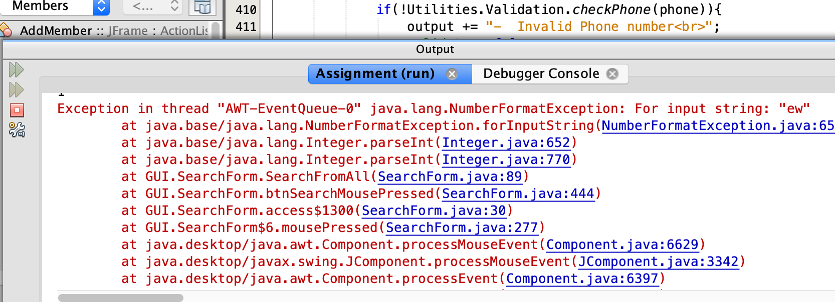

Resolution – Add try/catch block and throws NumberFormatException

